Anatomy and physiology of reproductive track
Student’s name
Institution
April 2021

Objectives/purpose/problem
The main purpose of the report was to trace the anatomy and physiology of reproductive track of a cow. A practical will be carried out and diagrams used to do demonstrations.
A good understanding of anatomy and physiology of a cow is important in managing reproduction of a cow.
This research will bring techniques for proper management of reproduction of a cow.
A 3-D model was designed to observe anatomy and physiology of a cow.
Introduction
A good understanding of anatomy and physiology of reproductive system of a cow is very important in achievement of proper cattle management system. This enables farmers to understand and control reproductive diseases in cows. There are two main parts in female reproductive system; the uterus whose main purpose is to hosting developing fetus, producing uterine and vaginal secretions and passing anatomically male sperms through the fallopian tubes; and ovaries that are responsible for producing anatomically female eggs cells and hormones such as estrogen and progesterone (Nabors, 2021). The physiology part of female reproductive system involves production of ova, certain sex hormones and maintenance of fertilized eggs as they are in process of developing into a mature fetus and becoming ready for delivery.

Hypothesis of the results
The main aim of performing the virtual experiment was to trace anatomy and physiology of reproductive track of a cow.
Anatomy includes study to get knowledge of structure of reproductive track while physiology involves the study of functions of reproductive track. Research and policies relating to sexuality of cows depend on anatomy and physiology of reproduction track.
The main function of anatomy in reproduction tract is; production of eggs and sperms, transporting and sustaining cells, nurturing developing fetus. The physiological function of the reproductive track is to produce eggs and maintain the fertilized eggs to develop into a mature fetus (Reece et al, 2017).
The diagram below shows the female reproductive system
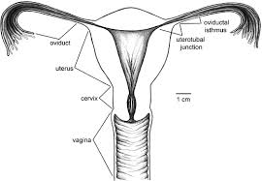

Apparatus
Microscope
Dissemination tools
Physiology data acquisition system virtual stimulations
Dairy cattle
Smartphone
Procedure
Point with a smart phone to the cow at the poster with cow image
Move the phone at different angles to see how the poster behaves
Ensure you are looking directly to the poster
Touch the head of the cow on the poster
Turn the view of the skeleton on or off
Give the cow some recombinant bST hormones and observe what happens to ovulation

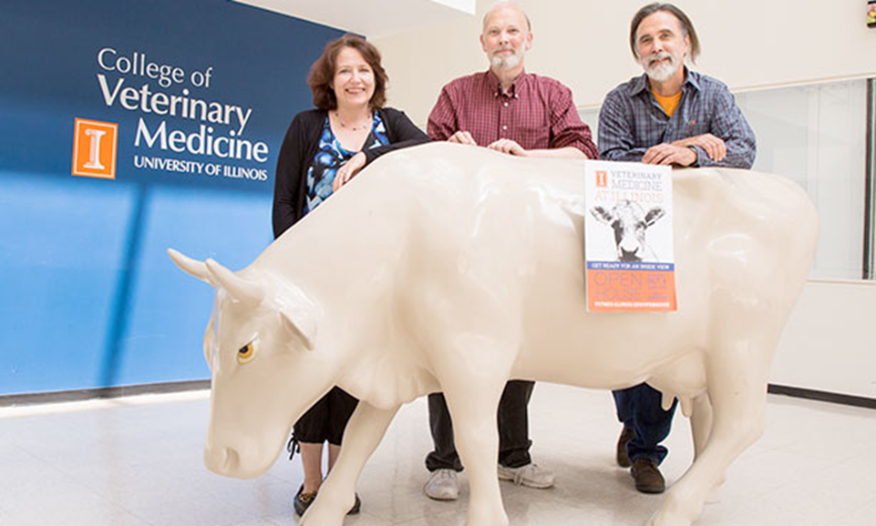
(Madyawati et al, 2019).

Observations
A small 3-D cow appeared skeleton, circulatory system, ovaries, uterus, liver, gall bladder and blood vessels.
It was observed that the ovaries, uterus and, fallopian tubes were attached to a ligament and that they were suspended into the pelvis canal and into the body system.
It was observed that the size of an ovary was 1.5 inches
It was observed that the oviduct lies between each ovary and adjacent tip of uterus and its shape is funnel shaped
It was observed that the size of oviduct is 10 inches.
When the cow was given recombinant bST hormones the rate of ovulation increased.
Results
The position of ovaries, fallopian tubes and uterus enables them to accommodate a growing fetus. The ovaries produce ovum and help in regulation of estrus cycle in a cow. Only one ovum is produced during estrus cycle.
Ovum is released in ovaries in a process called ovulation and they pass through the oviduct to uterus after fertilization. Fertilization takes place in oviduct.
In uterus there is development of maternal side of placenta for the purpose of nourishment of the developing fetus. Uterus has caruncles which provide a passage for exchange of nutrients between the cow and the fetus.
Conclusion
In conclusion, the reproductive track of a cow consists of uterus, fallopian tubes, ovaries, valve, vagina and cervix. The ovaries produce ova in a process called ovulation. The ova carry maternal genes. Estrogen, progesterone and relaxin are produced in ovaries. These hormones with the help of follicle stimulating hormones mediate the reproductive track of the cow. Structural abnormalities such as such as double cervix delay reproduction hence reproductive track of a cow should be keenly traced. A good understanding of reproductive anatomy increases conception rates and reproductive efficiency.

References
Nabors, B. (2021). Anatomy of the reproductive system of the cow. Bovine Reproduction, 249-257.
Madyawati, S. P., Srianto, P., Tyasningsih, W., Sudrajad, K., Tari, A. T. L., & Safitri, E. (2019). Screening the reproductive tract of dairy cattle for pathogenic micros. Indian Veterinary Journal, 96(3), 12-15.
Reece, W. O., & Rowe, E. W. (2017). Functional anatomy and physiology of domestic animals. John Wiley & Sons.

